**Our gratitude goes to**

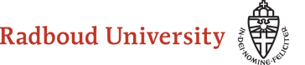

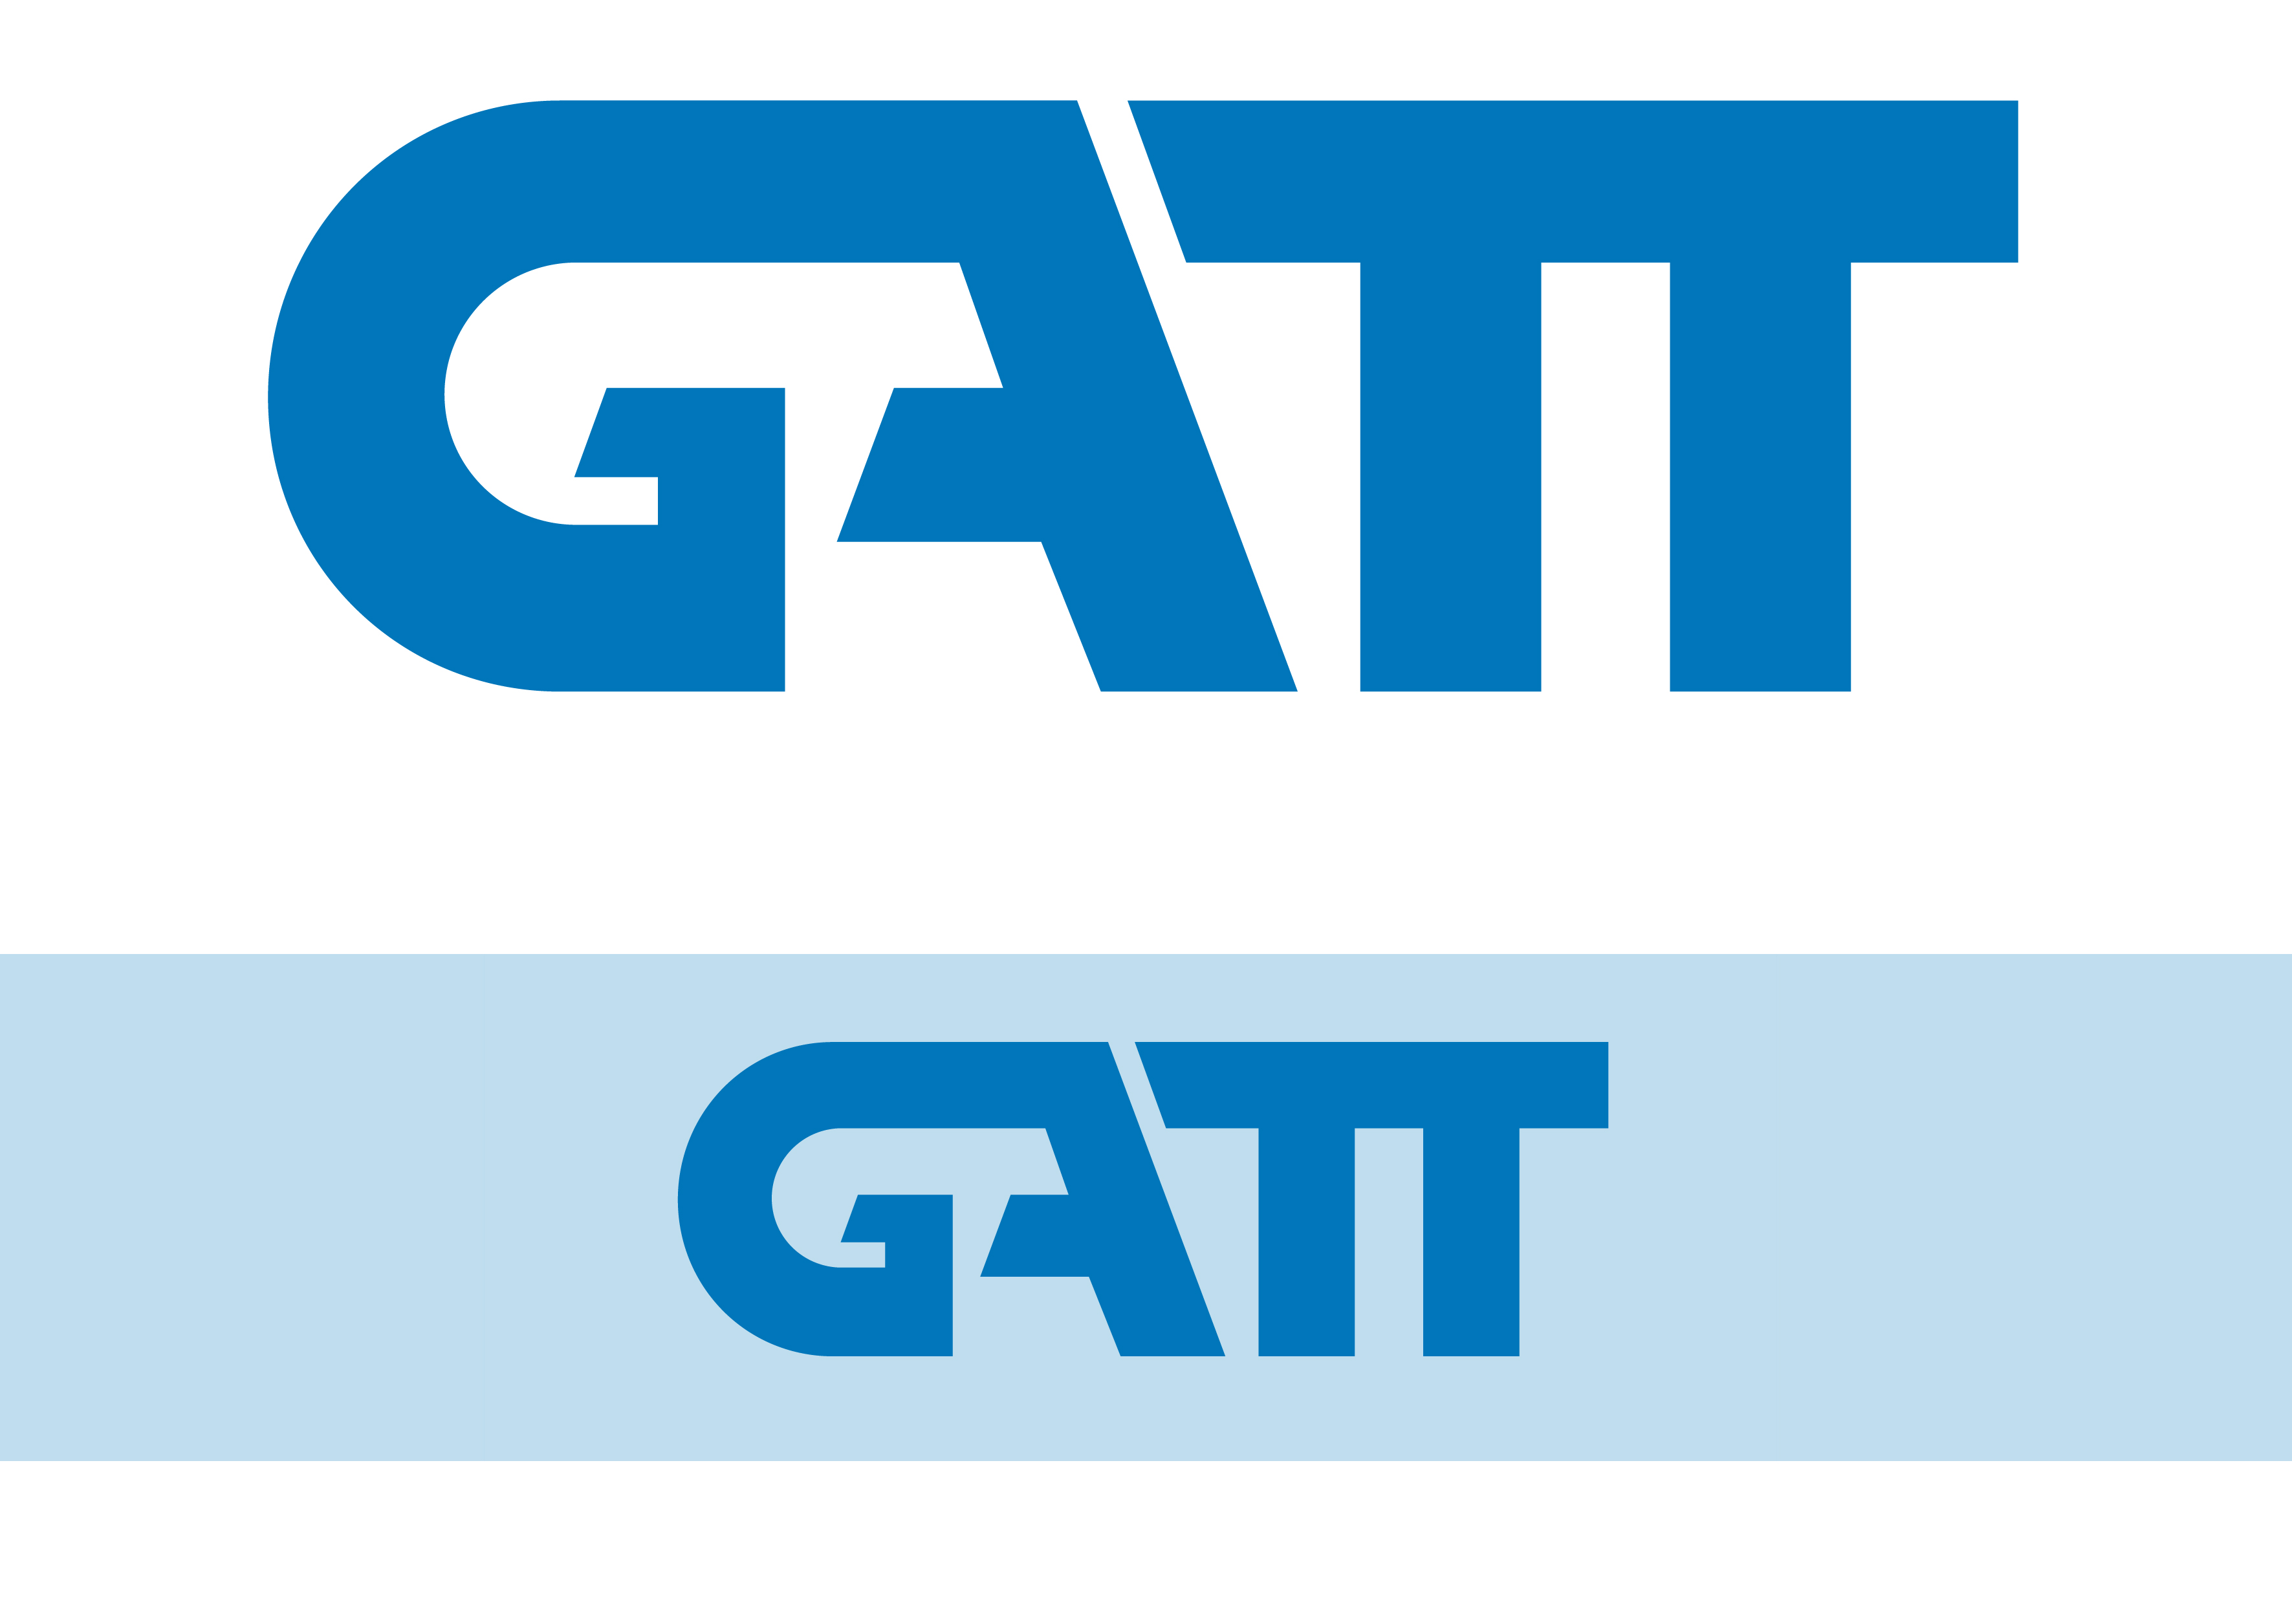

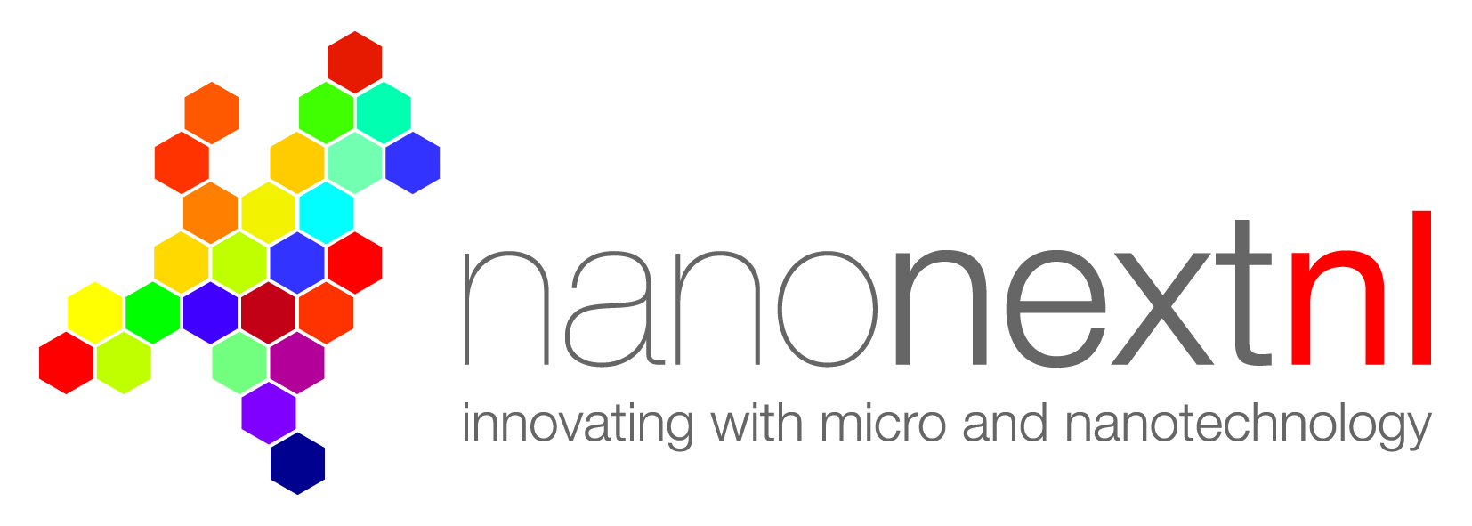

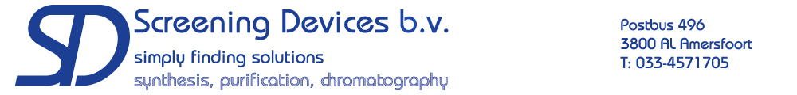

**Study Tour Sweden and Denmark**

**28 April - 11 May 2016**

Symposium 10 March 2016

Radboud University

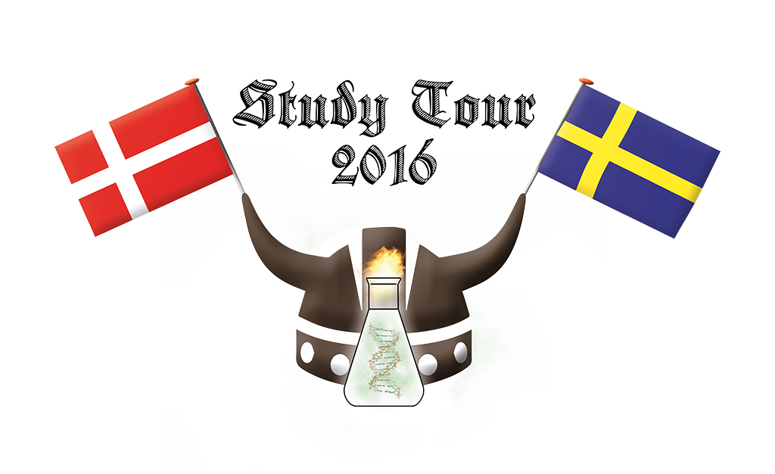

**Uppsala - Stockholm - Lund - Malmö - Copenhagen**

**Chemistry and Molecular Life Sciences in Sweden and Denmark**

Noor Smal

**Abstract**

Studying Chemistry or Molecular Life Sciences in Sweden or Denmark does not differ very much from studying it in the Netherlands. The university programs consist of three-year bachelors and two-year masters, with the bachelors being taught in the native language and the masters in English. A normal bachelor program consists of about three semesters of compulsory courses, a bachelor project of ~15 EC and elective courses. Both biochemistry and chemistry are taught at about half the universities. Many different specializations are offered in the master programs. These usually consist of 1 year of courses and 1 year with a masters project.

Both Sweden and Denmark spend a lot of money on higher education. This means students are able to study for free and are even given a monthly allowance during their studies. The two countries also spend a lot of money on R&D, in fact only Korea, Finland, Japan and Israel spend a larger percentage of their GDP on R&D. 14-15 of every 1000 people in Sweden and Denmark work as researchers, this number is only 8.5 in the Netherlands. Also, around 35% of these researchers are women, compared to 25% in the Netherlands.

Many Swedish and Danish scientists have been very important for our understanding of chemistry, like Niels Bohr of the Bohr model of atoms, Hans Oersted who first noticed the link between electrical current and magnetic fields and Jacob Berzelius, who invented chemical notation and terms like catalysis and polymers

**Timetable**

14.00 - 14.10 Opening (Tuur van den Eijnde)

14.10 - 14.30 The education system of Sweden and Denmark (Marjolijn den Boer)

14.30 - 14.50 The universities of Lund and Copenhagen (Dana te Brinke)

14.50 - 15.10 The history and international relationships of Sweden and Denmark (Roel Maas)

15.10 - 15.30 **Break**

15.30 - 15.50 The universities of Uppsala and Stockholm (Alain André)

15.50 - 16.10 Internship in Denmark (Lianne Lelieveldt)

16.10 - 16.30 Chemistry and Molecular Life Sciences

in Sweden and Denmark (Noor Smal)

16.30 - 16.50 Program (Johan Pijnenborg)

16.50 - 17.00 Closing (Tuur van den Eijnde)

17.00 - 18.00 **Drinks**

**The universities of Uppsala and Stockholm**

Alain André

**Abstract**

During the study tour we will visit the Universities of Uppsala and Stockholm. The University of Uppsala is the oldest university of Sweden, and the Nordic Countries founded in 1477. Over the centuries the university has grown, and is still high ranked in the top 100 universities worldwide. Great scientist as Anders Celsius and Carl Linnaeus had a professorship at this university. Nowadays the university have three disciplines with humanities and social sciences as the largest in number of faculties. At the faculty, and department, of Science and Technology the chemistry department can be divided in two departments. The Angstrom laboratory focus on materials and energy chemistry, and biomedical centre more on the life sciences.

Stockholm University started as a University College with goal for more openness and accessibility of the university in the society. In the 20th century Stockholm University grew to the largest university in Sweden. Nowadays over 70.000 students are studying here, and around 13% of these students have chosen a study at the science faculty. This university contains a lot of modern buildings, with for the science faculty the Arrhenius building, as the most important building. This building is named to Stockholm University’s Nobel Prise Laureate Svante Arrhenius for the discovery on how chemical compounds can carry electric current.

**Internship in Denmark**

Lianne

**Abstract**

Lianne has done her internship in Copenhagen and is going to tell us all about it. Think about how she found the spot, how she acquired the spot, but also about what she did during her internship. Further, she will tell us what to do before you go abroad, how daily life in Denmark is and what places she visited.

**The education system of Sweden and Denmark** Marjolijn den Boer

**Abstract**

The Swedish and Danish educational system are pretty comparable to the Dutch educational system. The biggest difference is in the age in which the education is compulsory. In Sweden and Denmark compulsory education starts at the age of six and takes nine years, where in the Netherlands this starts at the age of 4 and end when you turn 18, or when you get a secondary degree. However, even when education after 16 is not compulsory in Sweden and Denmark, almost all children attend it, because when you don’t, you are not allowed to enter preceding education and actually don’t have a chance.

Another difference is in the choice in education and when the children start to have a choice in what they want to learn and on which level they have education. Where in Sweden this actually only starts after the compulsory education, in Denmark and the Netherlands children have a choice a bit earlier, before the last few years of the compulsory education. Either on what level they want to follow education and in which direction.

After secondary school everything is kind of the same in all three countries, where it prepares student for all different kinds of working lives on different levels and jobs. Also after this education it is possible to do postgraduate education and get a doctors degree.

In Sweden there is a typical kind of student society called ‘the nations.’ They are comparable with our student societies, but a bit more intense and they are in charge of a lot more things. They exist at the two ancient universities at Uppsala and Lund and all students are required to be member of one of them. However, prior student were required to join the nation of their ‘own’ province, now they are allowed to pick the one they like.

**The universities of Lund and Copenhagen**

Dana te Brinke

**Abstract**

In the second half of our study tour, we will visit the universities of Lund and Copenhagen. Both are prestigious universities, ranked as 60th and 45th in the QS World University Rankings (2014), respectively. Lund University was founded in 1666, and is therefore the second oldest university of Sweden, after Uppsala. With its 42000 students, it is about twice as large as the Radboud University.

The education and research are spread over eight faculties, including a Faculty of Science with 1900 students and 14 Bachelor’s and 20 Master’s programmes. The university not only accommodates Research departments with a high international impact, but will also open two world-leading research facilities in the coming years: a synchrotron radiation facility (MAX IV laboratory) and a neutron source (European Spallation Source). The university’s library, botanical gardens and several museums are also known to be worth a visit. The small city of Lund, with its 83000 inhabitants, radiates an atmosphere strongly influenced by the very popular student societies and their traditions. The University of Copenhagen is the oldest university of Denmark, founded as early as 1479. It has 41000 students, which is comparable to Lund University. Among the six faculties, the Faculty of Science is very large with 9500 students, 56 study programmes (Bachelor’s and Master’s)

and 12 research departments in a wide range of the scientific field. Furthermore, the university houses a botanical garden and multiple museums. The city of Copenhagen is not characterized by its student life, but is known as a very cultural place.

**The history and international relationships of Sweden and Denmark**

Roel Maas

**Abstract**

Many historical events from Sweden and Denmark are aligned and can be told either from the Danish or Swedish side. The history of both countries starts with the Vikings. The Swedish Vikings travelled mostly east towards Russia and the Black and Caspian Sea. The Danish Viking travelled to the west, where they conquered England and traded and plundered all along the European coastline. After the Viking era, 800 – 1100, both countries started building their own monarchy. Although both countries had their own monarchy the kings lost more and more power to the nobles. Due to the lack of power of the king in Sweden and the turbulent years of no king et al in Denmark, the Scandinavian countries became united under one and the same monarch. This formed union is called the Kalmar Union. The Scandinavian countries were united in the Kalmar Union until its breakup in 1523. After the breakup of the Kalmar Union, both Denmark and Sweden fought some wars among each other to gain control over the Baltic Sea. During these times, both countries were strong kingdoms in Europe and the relationship with The Netherlands rose for both countries. Denmark held the control over the Baltic Sea, after the collapse of the Kalmar Union, and raised taxes for trade over the Baltic Sea. Much of Denmark’s wealth in that time came from the taxes The Netherlands needed to pay for their trade with Poland. When Denmark raised the tax, The Netherlands crossed over to the Swedes and helped defeating the Danish in the First Northern War. During the Second Northern War, The Netherlands fought along with the Danish to prevent Swedish full control over the Baltic Sea. In the Great

Northern War, about 1700, which was the third and last, the combined forces of Russia, Poland, Germany and Denmark defeated Sweden and the frontiers of the Scandinavian countries were set as they are still today. Which resulted in a shared control over the Baltic Sea, as was advantageous for the trade along the Baltic Sea for most European countries. Both countries developed to a welfare state during the industrial revolution, mid-19th century, and both countries raised a neutrality policy. Due to this, both countries remained neutral during the First World War. During the Second World War, occupation of Denmark by Germany led to the loss of neutrality of Denmark and it became a member of the NATO. Sweden has still a neutrality policy, as for today. Sweden has good international relationships with America, but the tension between Russia and Sweden can still be felt today. Greenland and the Faroe Islands still belong to the Danish kingdom and their foreign policies are thus controlled by Denmark. Both Denmark and Sweden have good relationships with The Netherlands, originating from the 17th century. One of the main export and import products between The Netherlands and Sweden and Denmark are chemicals. The Netherlands are, besides, one of the main investors in Swedish chemical sector.

**Word from the committee**

Welcome to our first official part of the study tour 2016. Today we will hear some presentations regarding education, universities and our studies Chemistry and Molecular Life Sciences. At the end we will present the program and have some drinks where you can meet your fellow students.

Over the last few months we have written many emails with the aim to organize an unforgettable study tour!

We are very excited and hope you are too.

Greetings,

the study tour committee 2016

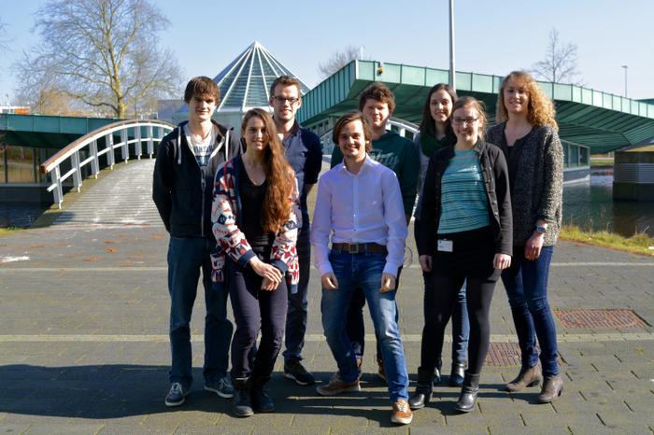

From left to right:

Johan, Eline, Willem, Tuur, Jon, Diana, Yvonne and Feija